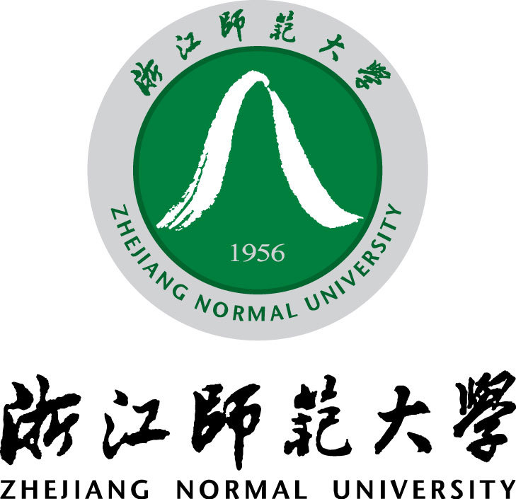

**TEAM MEMBERS:**

**ID 1: 201532120148**

**ID 2: 201532120138**

**CLASS: SOFTWARE ENGINEERING (151)**

**OBJECT ORIENTED DESIGN AND ANALYSIS**

**ATM description**

Contents

About ATM machines 3

Use of ATM machines 3

ATM components (Hardware and software) 5

Hardware 5

Software 5

ATM working mechanism 7

Inner working mechanism 8

Card Reader 8

Keypad 8

Speaker 8

Display Screen 8

Receipt printer 8

Cash dispenser 9

Cash dispenser functions 9

ATM Networking 9

# About ATM machines

An automated teller machine, also known as an automatic teller machine is an electronic telecommunications device that enables the customers of a [financial institution](https://en.wikipedia.org/wiki/Financial_institution) to perform [financial transactions](https://en.wikipedia.org/wiki/Financial_transaction), particularly cash withdrawal, without the need for a human [cashier](https://en.wikipedia.org/wiki/Cashier), clerk or [bank teller](https://en.wikipedia.org/wiki/Bank_teller).

According to the [ATM Industry Association (ATMIA)](https://en.wikipedia.org/wiki/ATMIA), there are now close to 3.5 million ATMs installed worldwide.

On most modern ATMs, the customer is identified by inserting a plastic [ATM card](https://en.wikipedia.org/wiki/ATM_card) with a [magnetic stripe](https://en.wikipedia.org/wiki/Magnetic_stripe) or a plastic [smart card](https://en.wikipedia.org/wiki/Smart_card) with a [chip](https://en.wikipedia.org/wiki/Integrated_circuit) that contains a unique card number and some security information such as an expiration date or [CVVC](https://en.wikipedia.org/wiki/Card_Verification_Value_Code) (CVV). Authentication is provided by the customer entering a [personal identification number](https://en.wikipedia.org/wiki/Personal_identification_number) (PIN) which must match the PIN stored in the chip on the card (if the card is so equipped) or in the issuing financial institution's database.

# Use of ATM machines

Using an ATM, customers can access their bank deposit or credit accounts in order to make a variety of transactions such as [cash](https://en.wikipedia.org/wiki/Cash) withdrawals, check balances, or credit mobile phones. If the currency being withdrawn from the ATM is different from that in which the bank account is denominated the money will be converted at an official [exchange rate](https://en.wikipedia.org/wiki/Exchange_rate). Thus, ATMs often provide the best possible exchange rates for foreign travelers, and are widely used for this purpose.

There are no hard international or government-compiled numbers totaling the complete number of ATMs in use worldwide. Estimates developed by [ATMIA](https://en.wikipedia.org/wiki/ATMIA) place the number of ATMs currently in use at 3 million units, or approximately 1 ATM per 3000 people in the world.

To simplify the analysis of ATM usage around the world, financial institutions generally divide the world into seven regions, due to the penetration rates, usage statistics, and features deployed. Four regions (USA, Canada, Europe, and Japan) have high numbers of ATMs per million people.

Despite the large number of ATMs, there is additional demand for machines in the Asia/Pacific area as well as in Latin America. [Macau](https://en.wikipedia.org/wiki/Macau) may have the highest density of ATMs at 254 ATMs per 100,000 adults. ATMs have yet to reach high numbers in the Near East and Africa.[[](https://en.wikipedia.org/wiki/Automated_teller_machine#cite_note-45)

The world's highest ATM is located at the [Khunjerab Pass](https://en.wikipedia.org/wiki/Khunjerab_Pass) in [Pakistan](https://en.wikipedia.org/wiki/Pakistan). Installed at an elevation of 15,397 feet by the [National Bank of Pakistan](https://en.wikipedia.org/wiki/National_Bank_of_Pakistan), it is designed to work in temperatures of up to -40 degree Celsius.[[46]](https://en.wikipedia.org/wiki/Automated_teller_machine#cite_note-46)

One of [the world's most northerly](https://en.wikipedia.org/wiki/The_world%27s_most_northern) installed ATMs is located at [Longyearbyen](https://en.wikipedia.org/wiki/Longyearbyen), [Svalbard](https://en.wikipedia.org/wiki/Svalbard), [Norway](https://en.wikipedia.org/wiki/Norway).

# ATM components (Hardware and software)

## Hardware

An ATM is typically made up of the following devices:

* [CPU](https://en.wikipedia.org/wiki/CPU) (to control the user interface and transaction devices)
* [Magnetic](https://en.wikipedia.org/wiki/Magnetic_stripe_card) or [chip card](https://en.wikipedia.org/wiki/Chip_card) reader (to identify the customer)
* [PIN](https://en.wikipedia.org/wiki/Personal_identification_number) pad EEP4 (similar in layout to a [touch tone](https://en.wikipedia.org/wiki/Touch_tone) or [calculator](https://en.wikipedia.org/wiki/Calculator) keypad), manufactured as part of a secure enclosure
* [Secure cryptoprocessor](https://en.wikipedia.org/wiki/Secure_cryptoprocessor), generally within a secure enclosure
* Display (used by the customer for performing the transaction)
* [Function key](https://en.wikipedia.org/wiki/Function_key) buttons (usually close to the display) or a [touchscreen](https://en.wikipedia.org/wiki/Touchscreen) (used to select the various aspects of the transaction)
* Record printer (to provide the customer with a record of the transaction)
* [Vault](https://en.wikipedia.org/wiki/Bank_vault) (to store the parts of the machinery requiring restricted access)
* Housing (for aesthetics and to attach signage to)
* Sensors and indicators

## Software

Today, the vast majority of ATMs worldwide use a [Microsoft Windows](https://en.wikipedia.org/wiki/Microsoft_Windows) operating system, primarily [Windows XP Professional](https://en.wikipedia.org/wiki/Windows_XP_Professional) or [Windows XP Embedded](https://en.wikipedia.org/wiki/Windows_XP_Embedded).

Small number of deployments may still be running older versions of the Windows OS, such as [Windows NT](https://en.wikipedia.org/wiki/Windows_NT), [Windows CE](https://en.wikipedia.org/wiki/Windows_CE), or [Windows 2000](https://en.wikipedia.org/wiki/Windows_2000)

There is a computer industry security view that general public desktop operating systems (os) have greater risks as operating systems for cash dispensing machines than other types of operating systems like (secure) [real-time operating systems](https://en.wikipedia.org/wiki/Real-time_operating_system) (RTOS). [RISKS Digest](https://en.wikipedia.org/wiki/RISKS_Digest) has many articles about ATM operating system vulnerabilities.

Except windows operating systems [Linux](https://en.wikipedia.org/wiki/Linux) is also finding some reception in the ATM marketplace. An example of this is [Banrisul](https://en.wikipedia.org/wiki/Banrisul), the largest bank in the south of [Brazil](https://en.wikipedia.org/wiki/Brazil), which has replaced the [MS-DOS](https://en.wikipedia.org/wiki/MS-DOS) operating systems in its ATMs with Linux. [Banco do Brasil](https://en.wikipedia.org/wiki/Banco_do_Brasil) is also migrating ATMs to Linux. Indian-based [Vortex Engineering](https://en.wikipedia.org/wiki/Vortex_Engineering) is manufacturing ATMs which operate only with Linux. Common application layer transaction protocols, such as [Diebold](https://en.wikipedia.org/wiki/Diebold) 91x (911 or 912) and [NCR](https://en.wikipedia.org/wiki/NCR_Corporation) [NDC or NDC+](https://en.wikipedia.org/wiki/NCR_Corporation) provide [emulation](https://en.wikipedia.org/wiki/Hardware_emulation) of older generations of hardware on newer platforms with incremental extensions made over time to address new capabilities, although companies like NCR continuously improve these protocols issuing newer versions (e.g. NCR's AANDC v3.x.y, where x.y are subversions). Most major ATM manufacturers provide software packages that implement these protocols. Newer protocols such as [IFX](https://en.wikipedia.org/wiki/Interactive_Financial_Exchange) have yet to find wide acceptance by transaction processors.

# ATM working mechanism

Nowadays, people do not carry money for shopping. Instead, they carry an automated teller machine card, also known as ATM Card. When money is needed they go to the nearby ATM machine, insert their ATM card, and take the required amount. As these ATM machines are found in most of the supermarkets, towns, and even hotels. In this section I will describe briefly on how the ATM is networked with the bank and the working of an ATM machine.

There are mainly two types of ATM’s which differ according to the way they operate. They can be called as

1. **Leased-line ATM**
2. **Dial-up ATM machines**

Any ATM machine needs a data terminal with two inputs and four output devices. Of course, for this to happen there should also be the availability of a host processor. The host processor is necessary so that the ATM can connect and also communicate with the person requesting the cash. The Internet Service Provider (ISP) also plays an important role in this action. They act as the gateway to the intermediate networks and also the bank computer.

A leased-line ATM machine has a 4-wire, point to point dedicated telephone line which helps in connecting it with the host processor. These types of machines are preferred in places where the user volume is high. They are considered high end and the operating costs of this type of a machine is very high.

The dial-up ATM machines only has a normal phone line with a modem and a toll free number. As these are normal connections their initial installation cost is very less and their operating costs only become a fraction of that of a leased-line ATM.

The host is mainly owned by the bank. It can also be owned by an ISP. If the host is owned by the bank only machines that work for that particular bank will be supported.

## Inner working mechanism

### Card Reader

This is a part of the identification of your particular account number. For this the magnetic stripe on the back of the ATM card is either swiped or pressed on the card reader so that it captures your account information. To understand the account information of the user, the data from the card is passed on to the host processor. The host processor thus uses this data to get the information from the card holder’s bank.

### Keypad

After the card is recognized, the machine asks further details like the type of withdrawal you prefer, your balance enquiry, and your personal identification number (PIN) and so on. Since each card has a unique PIN number, there is very little chance for someone else to withdraw money from your account. There are also separate laws to protect the PIN code while sending it to the host processor. So, the PIN number is mostly sent in encrypted form.

If your pin number is correct the ATM makes the necessary transactions for the required amount.

### Speaker

When a particular key is pressed, the speaker provides the feedback as audio.

## Display Screen

The questions asked by the ATM machine regarding the transaction and the input from the user is all displayed on the display screen. Each step of withdrawal is shown by the display screen. A CRT screen or even an LCD screen is commonly used as an LCD screen.

### Receipt printer

All the details regarding your withdrawal like the date and time and the amount withdrawn and also the balance amount in the bank is also shown in the receipt. Thus a paper receipt of the current transaction is obtained by the user.

### Cash dispenser

This is the central system of the ATM machine. This is from where the required money is obtained. From this portion the person can collect the money.

## Cash dispenser functions

As the whole mechanism is regarding the withdrawal of cash, the cash dispenser should be highly efficient.  ­These are the main functions that are to be carried out by the cash dispenser.

It is the duty of the cash dispenser to count each bill and give the required amount. If there are cases where the bills are stuck together they should be rejected and instead new notes should be taken. If the money is worn, or even folded, they will be moved to another section called the reject bin. All these actions are carried out by high-precision sensors.

There may be cases where the sensors may go wrong. To know this, the person responsible for the machine checks the number of rejected notes at a certain interval. If the numbers of notes are a lot than expected, then it would indicate that either the quality of the bills is not good or there is a problem with the cash dispenser.

A complete record of each transaction made by a particular ATM machine is recorded each day and is kept as a journal. This journal is later collected and then printed out at times. This information regarding the transaction is kept by the authorities for a period of 2 years. As there may be cases regarding a particular transaction going wrong, the account owner or also the bank officers have a right to see the transaction. With this printout the account holder can contact the host processor.

## ATM Networking

When a transaction is made, the details are inputted by the card holder. This information is passed on to the host processor by the ATM machine. The host processor checks these details with the authorized bank.  If the details are correct, the requested cash by the card holder is taken with the help of an electronic fund from the customer’s bank account to the host processor’s account. After this function is carried out, the processor sends an approval code to the ATM machine so that the cash can be transferred.